Binary logic
- Why binary? (transistors)
- Logic gates
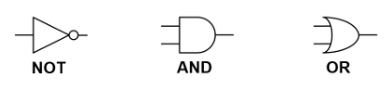
- Logic Statements:
P = T AND NOT(D)
Truth Tables
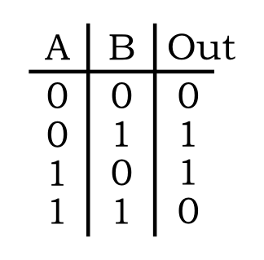
Central processing unit (CPU)
- Arithmetic & logic unit
- Control unit
- Registers (Memory Unit)
- Fetch-decode-execute
- Buses and their purposes
- The boot sequence
Features affecting performance:
- Clock speed (MHz, GHz)
- Cache memory
- Multiple cores

Hardware
- Definition
- Input devices
- Process devices
- Storage devices
- Output devices
- Von Neumann architecture
Memory
- Purpose
- Effect on Performance
- Random Access Memory (RAM) (Volatile)
- Read Only Memory (ROM)(Non-volatile)
- Virtual memory
- Flash memory
- Read/Write operations

Input devices
Move data into the computer
- Keyboard
- Mouse
- Touch screen
- Microphone
- Camera
- Sensor
- Bar code scanner
- Foot mouse
- Accelerometer
- GPS
- Braille keyboard

Secondary storage
- Magnetic hard disk
- Optical disk
- Flash memory
- Cloud Storage
Non-volatile
Internal/Removable
Considerations for selecting storage: Capacity / Speed / Portability / Durability / Reliability

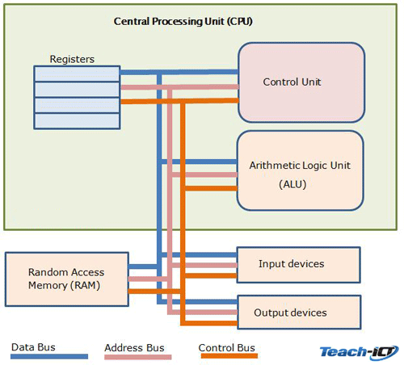

Computer Systems
The Input-Process-Output model
Different systems, pros & cons:
- Input-Process-Output model
- General-purpose systems
- Embedded systems
- Expert systems
Output devices
Move data out of the computer
- Monitor
- Printer
- Plotter
- Speakers
- Actuators
- LEDs

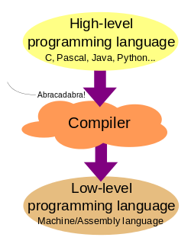
Types of Software
- Applications: Software for the End-User
  - Word processor
  - Spreadsheets
  - Image Editor
  - SIMS
  - Ticket booking system
- Utilities
  - Antivirus
  - Firewall
  - System clean up
  - Defragmentation
  - Task Manager
Programming languages.
- Low level languages:
  - Machine code (binary)
  - Assembly code
  - Mnemonics (MOV, CMP)
  - CPU-specific
- High level languages:
  - Source code
  - English-Like, Abstract
  - Compiled (C++)
  - Interpreted (Python)
  - Portable across devices
Software
Features and Purpose
- System Software
  - Operating System
  - Drivers
- Applications
- Utilities

System software
- Software that controls the hardware: OS and Drivers

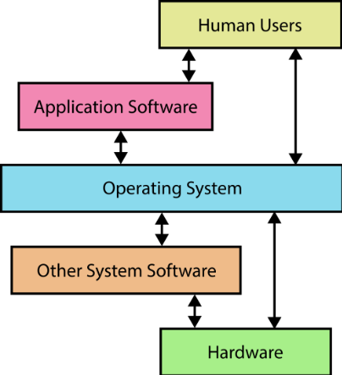

4.1.1 | understand the input-process-output model
4.2.1 | understand the function of the hardware components of a computer system (CPU, main memory, secondary storage, input and output devices) and how they work together
4.2.2 | understand the function of different types of main memory (RAM, ROM, cache)
4.2.3 | understand the concept of a stored program and the role of components of the CPU (control unit (CU), arithmetic/logic unit (ALU), registers, clock, address bus, data bus, control bus) in the fetch-decode-execute cycle (the Von Neumann model)
4.2.4 | understand how data is stored on physical devices (magnetic, optical, solid state)
4.2.5 | understand the concept of storing data in the ‘cloud’ and other contemporary secondary storage
4.2.6 | understand the need for embedded systems and their functions
4.3.1 | be able to construct truth tables for a given logic statement (AND, OR, NOT)
4.3.2 | be able to produce logic statements for a given problem
4.4.1 | know what an operating system is and how it manages files, processes, hardware and the user interface
4.4.2 | understand the purpose and functions of utility software (managing, repairing and converting files; compression; defragmentation; backing up; anti-virus, anti-spyware)
4.4.3 | understand how software can be used to simulate and model aspects of the real world
4.5.1 | understand what is meant by high-level and low-level programming languages and understand their suitability for a particular task
4.5.2 | understand what is meant by an assembler, a compiler and an interpreter when translating programming languages and know the advantages and disadvantages of each.

Programming software
- Editors / IDEs
- Translators
  - Compiler
  - Interpreter
  - Assembler
- Pros and Cons of
different translators

Security
- Malware (viruses)
- Patching
- Authentication
- Access Levels
- Encryption
- Back-ups
Simulation & Modelling
- Purpose of Modelling
- Pros and Cons
- Modelling Software

FAQ’s
Does ROM store the operating system?
No. The operating system is stored on secondary storage. ROM holds BIOS which locates all of the hardware prior to the operating system loading. It will then get the processor to load the OS by pointing to where it is stored.
Why does RAM not always speed a computer up?
Adding more RAM to a system will only help if the RAM that is currently installed is always filled to 100% and more space is needed.
Is flash memory really memory?
Yes. Flash memory is different to RAM though as it is non-volatile.
http://computer.howstuffworks.com/flash-memory.htm
Do students need to understand how the different types of storage work?
Students do not need to learn about how each one functions, but they need to know how the data is stored e.g. using magnetised elements, lasers, logic circuits.
Does a Defragmentation tool need to be run on both a standard magnetic hard disk drive and a solid state drive?
No. The reason that it is important to use a defragmentation tool on a magnetic disk drive is because the read/write arm has to move to desired track/sector.
Solid state drives have no moving parts and therefore it doesn’t make a noticeable different to the speed of reading fragmented data.
Drives can be optimised, but it can do more harm than good trying to defragment a solid state drive.
What is a penetration tester?
A penetration tester tests a computer system, network or web application to find vulnerabilities that an attacker could exploit.
How can companies protect themselves from SQL injection?
Similar to using a virus scanner on a computer, patches are released to protect against vulnerabilities.
Will anti-virus protect a computer from all viruses?
Anti-virus companies release patches to protect against vulnerabilities they have recognised, similar to that of operating system manufacturers. New threats are emerging daily therefore it is up to the manufacturer to develop a patch and for it to be implemented on a system constantly to provide the best security possible.

Misconceptions
Students refer to their USB memory stick as a USB. USB is a connection protocol, not a storage device. A USB memory stick is a solid state storage device that connects to the PC through a USB Port.
When recalling optical, students often associate it with vision, not the use of lasers and light.
Students often say things are “faster”; Students must be confident that they understand transfer speeds. E.g. All storage devices will appear to transfer the 10KB files very quickly - but for large files - SSD would be the fastest due to its data transfer speeds.
Judging the “best devices” for use; It may be that there are other justifications for using mediums compared to ones that may appear obvious - where students provide well supported arguments for use/selection of a storage device, award credit. E.g. Choice of medium for a PC - you could argue SSD or Magnetic HDDs are the best option - dependent on circumstances.
Virtual memory is only created and used if needed, as it is much slower than RAM. Virtual memory is controlled/created by the Operating System.
Some people refer to Storage Space as memory; In computers, memory management refers to the computer's primary memory – which is the RAM (Random Access Memory). There is often a misconception that storage space on the hard disk drive is called memory – with comments “the hard disk drive is out of memory – I therefore have to delete some files” being made. Storage Space refers to any long term storage of data and memory management refers to the management of the computer's RAM (for short term storage of data and instructions)
Multi-tasking; The processor completes lots of processes at exactly the same time. The processor divides its time up between processes – therefore it appears to complete many processes at the same time, but actually the processor is allocated to each task for a very small amount of time before moving onto the next task.
Each process is said to be given a time slice of the processor. To a user it appears that all tasks are taking place at the same time. However multi-core processors, technically can have more than one process at the same time, but only because there are more “cores” (processors) each doing one thing at a time.
Confusion between worm and a virus; Worms and viruses replicate in order to spread however worms do not need to attach themselves to a program unlike viruses.

Edexcel 9-1 Computer Science Specification:
This is what Edexcel say you need to know… Do you?
Topic 4 - Computers | 4.1 | Machines and computational modelling | 4.1.1 | understand the input-process-output model
Topic 4 - Computers | 4.2 | Hardware | 4.2.1 | understand the function of the hardware components of a computer system (CPU, main memory, secondary storage, input and output devices) and how they work together
Topic 4 - Computers | 4.2 | Hardware | 4.2.2 | understand the function of different types of main memory (RAM, ROM, cache)
Topic 4 - Computers | 4.2 | Hardware | 4.2.3 | understand the concept of a stored program and the role of components of the CPU (control unit (CU), arithmetic/logic unit (ALU), registers, clock, address bus, data bus, control bus) in the fetch-decode-execute cycle (the Von Neumann model)
Topic 4 - Computers | 4.2 | Hardware | 4.2.4 | understand how data is stored on physical devices (magnetic, optical, solid state)
Topic 4 - Computers | 4.2 | Hardware | 4.2.5 | understand the concept of storing data in the ‘cloud’ and other contemporary secondary storage
Topic 4 - Computers | 4.2 | Hardware | 4.2.6 | understand the need for embedded systems and their functions
Topic 4 - Computers | 4.3 | Logic | 4.3.1 | be able to construct truth tables for a given logic statement (AND, OR, NOT)
Topic 4 - Computers | 4.3 | Logic | 4.3.2 | be able to produce logic statements for a given problem
Topic 4 - Computers | 4.4 | Software | 4.4.1 | know what an operating system is and how it manages files, processes, hardware and the user interface
Topic 4 - Computers | 4.4 | Software | 4.4.2 | understand the purpose and functions of utility software (managing, repairing and converting files; compression; defragmentation; backing up; anti-virus, anti-spyware)
Topic 4 - Computers | 4.4 | Software | 4.4.3 | understand how software can be used to simulate and model aspects of the real world
Topic 4 - Computers | 4.5 | Programming languages | 4.5.1 | understand what is meant by high-level and low-level programming languages and understand their suitability for a particular task
Topic 4 - Computers | 4.5 | Programming languages | 4.5.2 | understand what is meant by an assembler, a compiler and an interpreter when translating programming languages and know the advantages and disadvantages of each.

