  Christmas Computation  Challenge  for all Year 7, 8 and 9 students at WHGS  FEATURING · Code-breaking challenges, mind-bending puzzles and fun computational-thinking activities!  prizes available for best entries by 14th January 2019  Use extra paper if you need to. Attach everything and hand in at S7 before the deadline to be in with a chance of a prize. You MUST attempt at least three challenges!  Warning: also Contains Geeky Humour like this:-  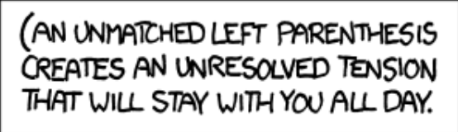 | puzzle 1:  It's all in our Genes…  Convert the word ALICE into the word GENES in 13 steps or less. You must only change one letter of the word on each step. On every step you should have created an English word that is in the dictionary. ALICE in  Wonderland was written by Lewis Carroll, who also invented this kind of puzzle. The binary version of the word ladder is called Gray code - a way of encoding numbers. Our bodies encode information using the 4 symbols  of DNA rather than the 2 of binary. Its all in our GENES  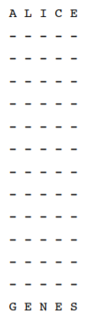
A wife calls her programmer husband and tells him,
"While you're out, buy some milk."

He never returns home.

255 bumps into 254 in the street, and asks him "Are you ok?" and 254 says "Yeah, just a bit down".

There are 10 types of people in the world, those that understand binary and those that don't.

Why do programmers always mix up Halloween and Christmas? Because Oct 31 == Dec 25

computing jokes
2. Debugging Spot the Difference
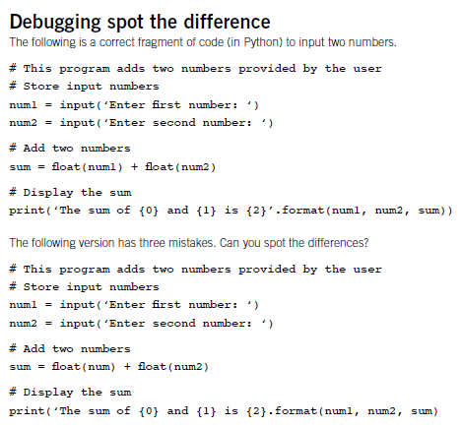

3. The Bridges of Königsberg
Below is a map of the city of Königsberg, showing the river that runs through the middle, its two islands and the seven bridges that cross the river.

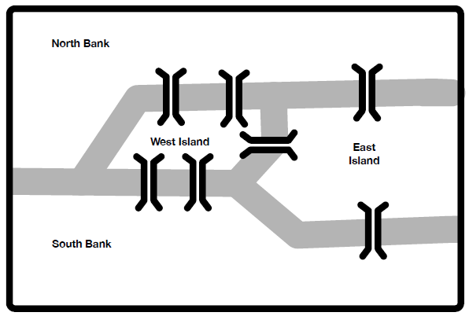
The tourist information centre would like to publish a route that visits each part of the city (both banks and both islands) and that crosses each bridge once (and no more).

It should start and end in the same place.

You have been asked to advise them. Either provide a route that works, or if you can’t, explain why it is not possible.

Message a  76FB5D  7CCCF0B9D | Codebook a  0 [... ]  1 [, ]  2 [aim]  3 [approach ]  4 [development).]  5 [fast ]  6 [fire, ]  7 [Ready, ]  8 [software ]  9 [slow ]  A [to ]  B [(the ]  C [21]  D [3A84]  E [ ]  F [2E]
Message b  9JI  D8CA  37 JI  35AE  369IB  K40F8A  G6HK41A  341A 35 8. | Codebook b  0 [fleas]  1 [still]  2 [have]  3 [and ]  4 [greater ]  5 [so]  6 [those ]  7 [lesser]  8 [on]  9 [great ]  A [,]  B [themselvesA in turnA]  C [ their backs to bite ‘em]  D [up]  E [ad infinitum.]  F [ to go ]  G [while ]  H [again ]  I [0A]  J [0 K7 ]  K [2 ]
4. Compression codes
Repeatedly replace the characters in the compressed messages on the right by those from the corresponding codebook (the characters between the square brackets) to reveal a computing quotation and a poem credited to Augustus De Morgan, the great mathematician and tutor of ‘first programmer’ Ada Lovelace.

The "dictionary" principle used here is a kind of lossless compression and is really used to compress text files in the .zip format.

5. Logical Thinking – Who Eats at Quonk?

A group of friends, two women (Alice and Babs), and two men (Zach and Yabu), like to pair up to go out on dates to cool restaurants.

There are four combinations they date in (Alice-Zach, Alice-Yabu, Babs-Zach and Babs-Yabu).The favourite restaurant of one of the men and one of the women is a place called Quonk.

However if those two eat together they always try new restaurants as do the other pair if together.

Therefore when exactly one, and only one, of the particular man and woman in question is on a date they eat at Quonk. When Alice goes out with Zach they go to Quonk. Which, if any, other pair from those below eat at Quonk:

1) Alice and Yabu,
2) Babs and Zach,
3) Babs and Yabu, or
4) none of the other pairs eat at Quonk?
If you have enjoyed these puzzles, why not come to the Club? And choose the Computer Science GCSE!

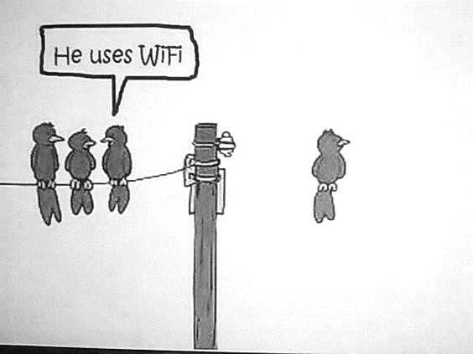
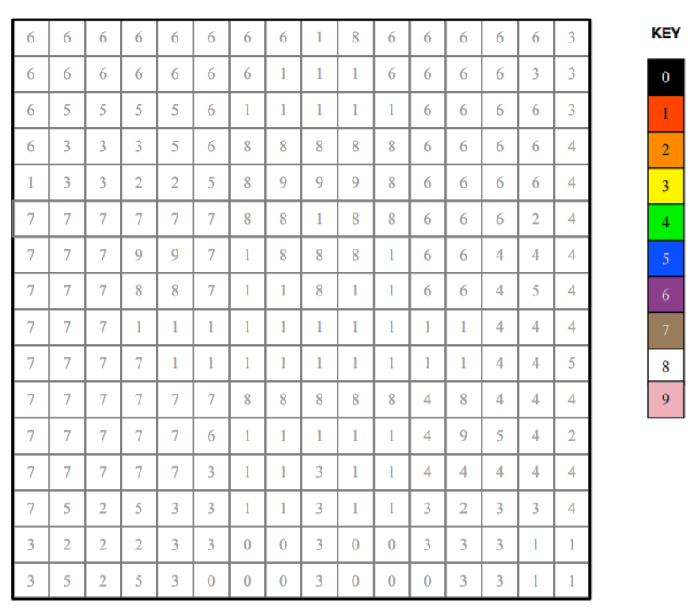
6. Pixel puzzle
Pictures can be stored in a computer as a grid of numbers. Each number gives the colour of that small area or pixel. This is also the way digital images are stored and represented on a screen.

Recreate the picture by colouring each pixel as given by its number. Look up the colour for each number in the key. For example, colour pixels marked 0 in black, and pixels marked 1 in red.

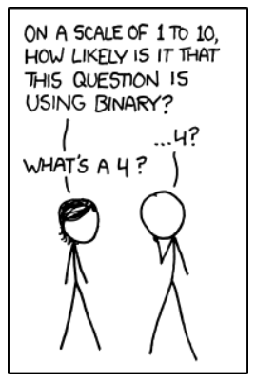
7. Card Sorting with Logic
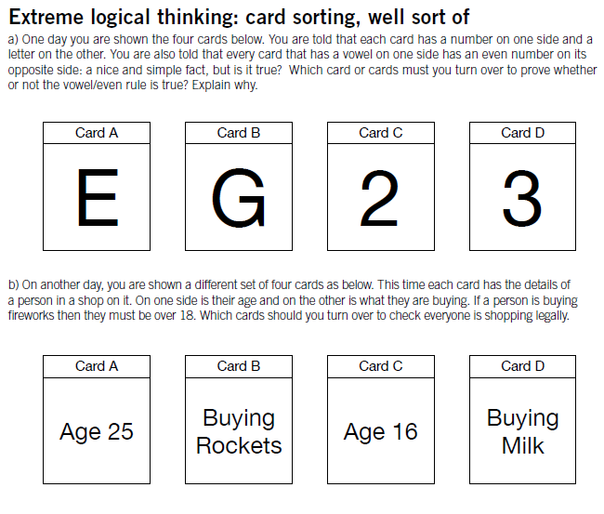
There's no place like 127.0.0.1

Tiebreak: Explain the jokes. If top scores are tied, the winner will be the entry which explains all the humour in this booklet successfully. Have a lovely holiday!

